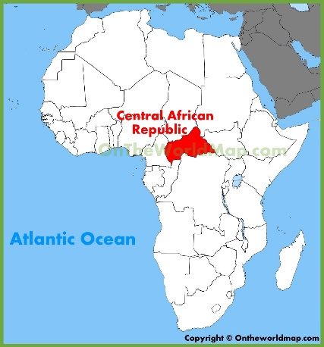
Name:
Section:
War in the Central African Republic

- Who used to control the Central African Republic?

- How does the conflict impact civilians?

- What images do you see in the video that shows how Africa is underdeveloped?

- Describe the religious conflict.

- After viewing the video, how does this connect with our unit?

