Name/Class #:
Section:

Unification of China
Directions: Using your notes, textbook, PowerPoint found in the email, and the resources in this handout, please complete the four parts of this handout.

Part One: An Overview of the Chinese Systems of Belief
Directions: Look at chart on the board and answer the following questions.
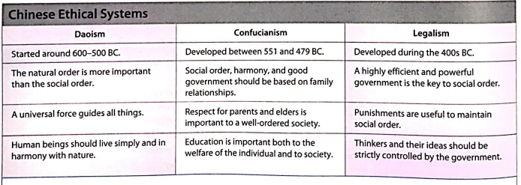

- What is the main idea of Confucianism?

- What is the main idea of Daoism?

- What is the main idea of Legalism?

- Which of these three systems stressed the importance of government and a well-ordered society?

- Which of these systems seems to be the most moderate and balanced? Explain.

- Why do you think Legalism prevailed as the way to end the warring states period?

Part Two: Shi Huangdi’s Method of Controlling the Qin Empire
Directions: Read “The Empire of Qin” on the last page of this handout and evaluate China’s first emperor by creating a chart that summarizes the positive advances of the central government and the totalitarian actions and attitudes. You can bullet point your answers.

Positive Advances of the Central Government | Totalitarian Actions and Attitudes

Part Three: Method of Controlling an Empire: Comparison
Directions: Using your handout from Day 6, write down the methods that the Assyrian and Persian Empire did to control their vast area of land. Then, using the table above, fill in information about the Qin. Finally, highlight or circle the similar aspects among the three.

Assyrian Empire | Persian Empire | Qin Empire

Part Four: Overall Questions:
- Why was Legalism, and not Confucianism or Daoism, able to prevail as a way to end the warring states period?

- What were positive and negative aspects of the Qin Dynasty?

The Empire of Qin

Directions: As you read, take note of how China’s first emperor employed both positive advances of the central government and also totalitarian actions and attitudes.

In 245 BC, Ying Cheng became king of the Qin when he was only thirteen years old. As he grew in age, wisdom, and power, he developed the dream of realizing the Confucian ideal of a united China under one ruler. He declared himself Shi Huangdi, First Emperor, establishing the Rule of Emperors that would last in China until 1911. The name China comes from the time of his rule, when Shi Huangdi transformed China from a feudal state into a powerful kingdom with a centralized government.
To solidify his power, Shi Huangdi built a mobile army of chariots and cavalry armed with iron swords and bow. He moved the old aristocrats and feudal lords to the capital and demanded the surrender of their weapons. To defend China against the barbarian invaders from the north, he built the Great Wall of China--which, at 1500 miles long is the only human-made object visible from space.
He established a central government which standardized weights and measures, coinage, roadways, and legal codes, and implemented a standardized, written script that could be read not only by speakers of China’ many regional dialects then, but also by the Japanese, the Koreans, and the Vietnamese later. To finance the building and operation of this central government, Shi Huangdi also established national taxation.
The old adage (saying) that power corrupts, however, proved true, and the first emperor became a totalitarian ruler. He created a system of spying through his military governors and civil administrators in the provinces and monopolized all basic goods. In an effort to produce intellectual conformity, in 213 BC, he ordered the burning of books, especially Confucian classics. However, he saved works of medicine, legal philosophy, and magic, which reflected his utilitarian attitude toward learning, ironically balanced with his interest in superstition. Soon he became a paranoid recluse, dodging assassination attempts on his life.
The discovery of his burial site in Shaanxi province in 1974 has unearthed 8,000 life-sized terracotta soldiers. The main tomb, yet to be excavated, is expected to rival the tomb of King Tut in Egypt for splendor, art, and cultural artifacts.

