Name________________________________ Date__________________

The Yellow River Valley in Chinese History (excerpts)

China has had the good fortune to have two great rivers: the Yangtze, and the Yellow River or Huang He.

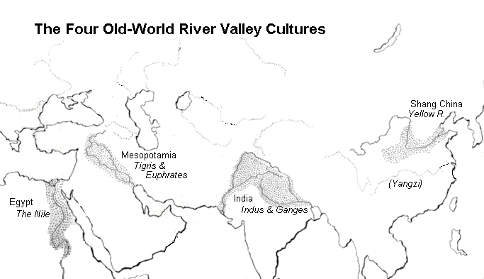

The Yellow River is also known as the "cradle of Chinese civilization" or the "Mother River." Usually a source of rich fertile soil and irrigation water, the Yellow River has transformed itself more than 1,500 times in recorded history into a raging torrent that swept away entire villages.
As a result, the river has several less-positive nicknames as well, such as "China's Sorrow" and "Scourge of the Han People." Over the centuries, the Chinese people have used it not only for agriculture, but also as a transportation route and even as a weapon.
…The river runs across central China's loess plains, picking up an immense load of silt, which colors the water and gives the river its name.

The Yellow River in Ancient China
The recorded history of Chinese civilization began on the banks of the Yellow River with the Xia Dynasty (c. 2100 to c. 1600 BCE). According to Sima Qian's "Records of the Grand Historian" and the "Classic of Rites," a number of different tribes originally united into the Xia Kingdom in order to find a solution to devastating floods on the river.
When a series of breakwaters failed to stop the flooding, the Xia instead dug a series of canals to channel excess water out into the countryside and then down to sea.
Unified behind strong leaders, and able to produce bountiful harvests since Yellow River floods no longer destroyed their crops so often, the Xia Kingdom ruled central China for several centuries. The Shang Dynasty succeeded the Xia around 1600 BCE, lasting until 1046 BCE, and also centered itself on the Yellow River valley. Fed by the riches of the fertile river-bottom land, the Shang developed an elaborate culture featuring powerful emperors who built huge palaces for themselves and massive walls to guard their kingdoms. Trade was conducted throughout China along the rivers and canals. Priests guided people through divination using oracle bones, and artists and craftsmen produced jewelry and art artwork using jade, a soft stone.

Oracle Bones

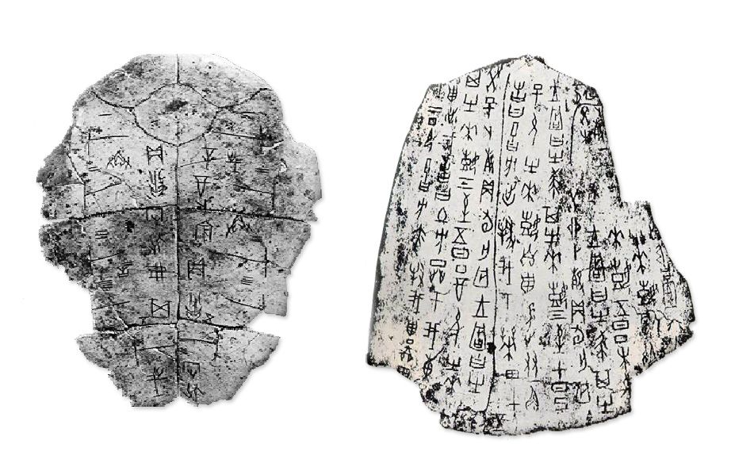

When that era came to an end, the country plunged into the Warring States Period (256 - 221 BCE). One favorite tactic of the various warring states was to send saboteurs to break Yellow River dams or divert canals on neighboring kingdoms' domains, causing flooding and misery. This is the first, but by no means the last, recorded instance of people using the river as a weapon.
…The Yellow River is the surging heart of Chinese civilization. Its waters and the rich soil it carries bring agricultural abundance to support China's enormous population. However, this "Mother River" has always had a dark side, as well. When the rains are heavy, or silt blocks up the river channel, she has the power to jump her banks and spread death and destruction across central China.

Source: Kallie Szczepanski, “What Role has the Yellow River Played in Chinese History?” Asian History, About.com, 2015.

