Name: Section:

Part One: Understanding the Neolithic Revolution
- What does a civilization need in order to be “complex”? Why is it necessary?

- Why is the date 11,000 BC significant?

- Why did humans migrate?

- Where did humans migrate?

- What is the Neolithic Revolution?

Part Two: The Neolithic Revolution leads to Complex Civilizations
In groups organize these phrases in order to correctly explain how the Neolithic Revolution leads to a complex civilization.
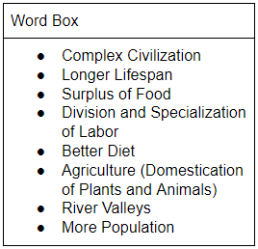
Step 1:

Step 2:

Step 3:

Step 4:

Step 5:

Step 6:

Step 7:

Step 8:

In one to three sentences, summarize this process:

Part Two: Guns, Germs, and Steel

As you watch this clip, list examples explaining how the Neolithic Revolution allowed civilizations to grow.

