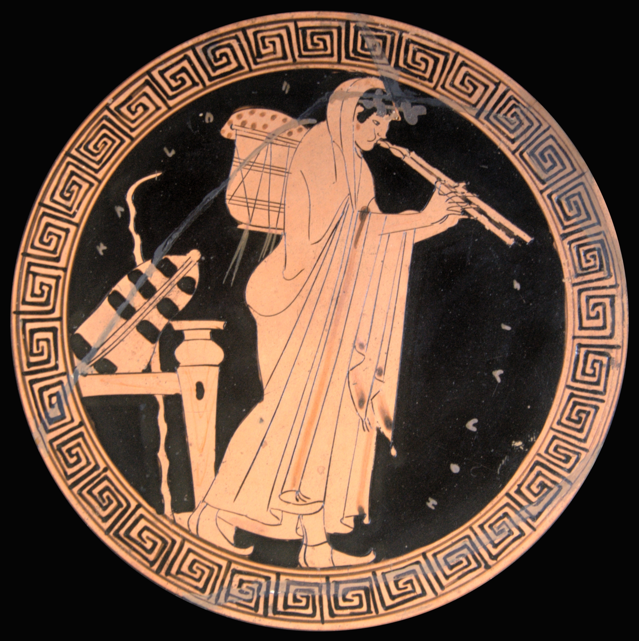
Enrichment LAP 3
Greek Mythology in Advertisement

Today, your task is to research Greek Myths, Greek Gods and Goddesses to find traces of Greek Mythology in modern day companies. Companies today will reference Greek Mythology in their logos or company names. Your job is to find these companies and research the myth they reference and the company itself. Then you will find examples of the Greek reference in advertisements. Finally you will present your findings to the class and discuss the connection that the company hopes the consumer will make between the product and the Greek myth.

List of Companies to Choose:

- Ajax
- Amazon
- Eos
- Mars Bar
- Olympus
- Nike
- NBC
- Midas
- Honda Odyssey
- Goodyear
- Pandora (jewelry or music)
- Venus
- Mobil
- Trident

Step 1: Choosing a Company
- Look at the list provided and conduct quick research to decide which one you want to explore
- When you are secure in you choice in a company write it on the board so the class knows that it is taken

Step 2: Researching the Mythology
- Research the myth/god/goddess that your company references
- Summarize the myth story into a PowerPoint slide (try to include more pictures than words!)

Step 3: Research the Company
- Research the company that chose the Greek reference as their logo or name (or both)
- Summarize this company’s story into a PowerPoint slide (try to include more pictures than words!)
  - Include: When they started, what they sell, and why they chose the name/logo

Step 4: Find the Advertisements
- Find 3-5 of your company’s advertisements that references to the Greek Myth—these can include commercials, images, magazines, newspapers, etc.
- Place these in your PowerPoint as well

Step 5: Make the Connection
- Answer the question: Since this company chose to name or brand it’s company after a Greek Myth, what connection does this company want it’s consumers to think about their product?

Include in PowerPoint
- Title slide with company name, logo, and Greek Myth reference
- Myth story
- Company story
- 3-5 advertisements
- Answer to connection question

