Name:
Section:
Middle East: Cultural Crossroads, Standard
Directions: Today we will travel around the Middle East to read information and study images in order to understand the cultures of the citizens. As you travel to different stations, please answer the questions that follow the corresponding station. You will ultimately be attempting to answer the Essential Question of today’s lesson which is the following:
The Middle East is at the crossroads of the world; how does this impact the citizens?

Station 1: Governments
1. Which country, according to the chart, has a dominant-party form of government? Name that party.

2. How many countries on the chart have kings? Name the countries.

3. Which two countries have a presidential-parliamentary form of government? Name an important difference.

Station 2: Ethnicities
1. Read about the ethnic groups of Iran, then study the map and graph. How do the Iranian government policies contradict the actual events?

2. How do you think the ethnic diversity in Iran impacts the everyday citizens?

Station 3: Languages
1. As you read, please label map the locations of the language groups with the assigned colors listed below.
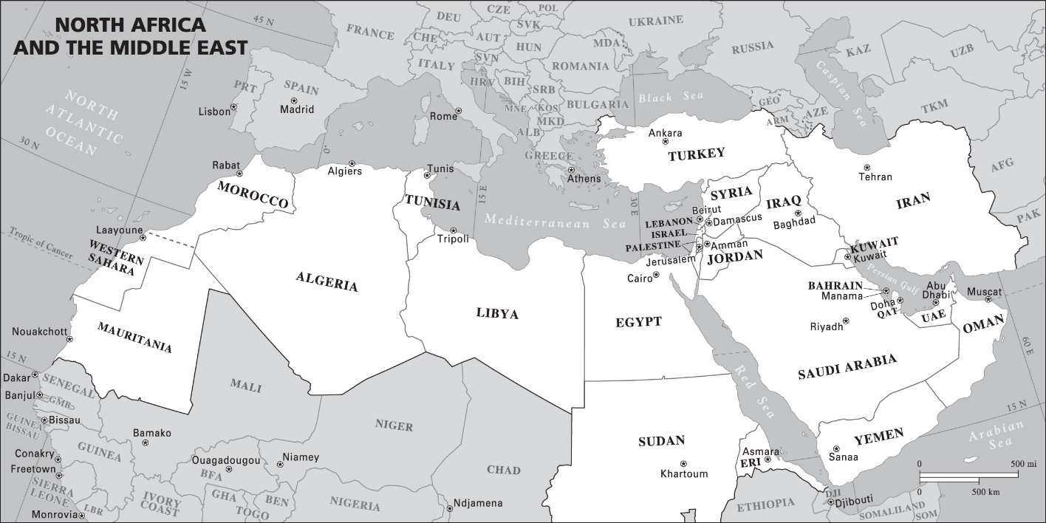
Yellow: Arabic
Red: Persian/Farsi
Blue: Hebrew
Green: Turkish
Orange: Kurdish
2. How do you think this language diversity impacts the everyday citizens?

Station 4: Daily Life
1. In your opinion, and to the best of your ability, rank the images by number in the following fashion:
Very different from American daily life
Very similar to American daily life

2. Explain your results:

