Name: Section:
Map of Greece: Day 1
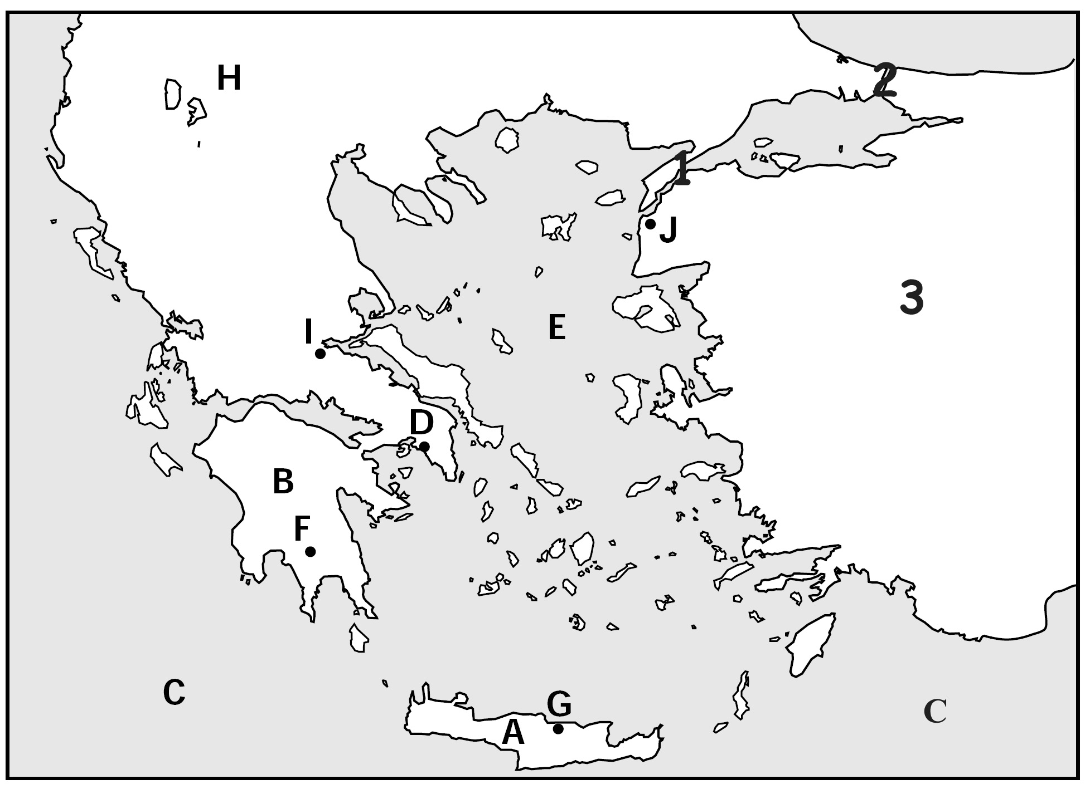
Part One: Blank Map
Directions: As your class answers the quiz questions together, fill in the boxes with the correct answers.

A | B | C | D | E | F | G
H | I | J | 1 | 2 | 3

Part Two: Physical Map of Greece
- List the physical features you see on these maps.

- Where are most people likely to settle? Why? (Hint: Think about where the city-states have formed)

- What challenges did geography create for settlement in Greece and how do you think people dealt with those challenges?

