Name: Section:
Lap 2 Map Activity→ EQ: How did the establishment of religion and trade influence the early empires of India, China, and Africa?

Directions: In order to understand why people migrated in the Early Eastern Empires, we need to know where they were. Complete the following map by using any source you would like. You may label using highlighter, colored pencils, markers,crayons, or simply using a pencil.
- Label the major empires we will discuss in this Lap:
  - Hittite Empire (2000 BC)
  - Kush Empire (700 BC)
  - Assyrian Empire (650 BC)
  - Persian Empire (500 BC)
  - Chinese Empire→ Qin Dynasty (221 BC) and Han Dynasty (206 BC)
  - Gupta Empire (320 AD)
- Label where the major world religions originated:
  - Buddhism
  - Hinduism
  - Judaism
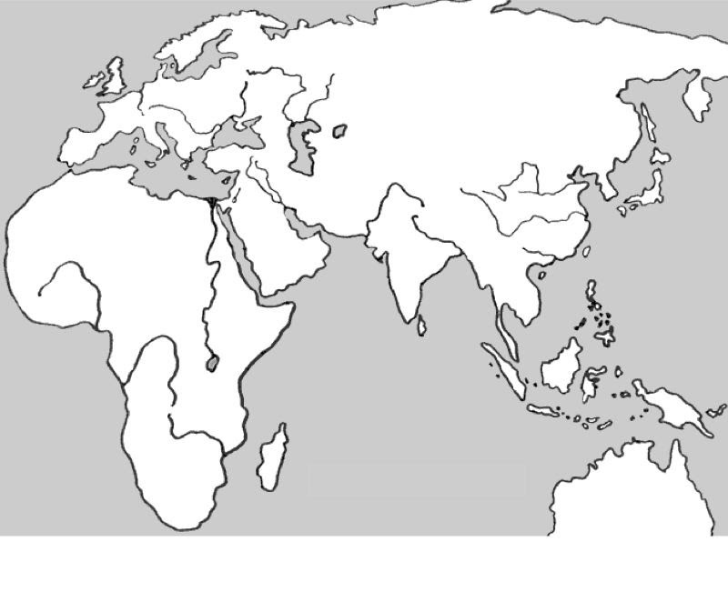
  - Zoroastrianism
  - Confucianism

