Name_______________________________ Date____________________

“How to Succeed in Sumer” by Henry Abraham and Irwin Pfeffer

Over 7,00 years ago, people began to settle in a wide valley between the Tigris and Euphrates rivers, in the southern part of a land called Mesopotamia. (Today, this country is called Iraq.) To the south and west of this land were the Syrian and Arabian deserts. To the east and north were the mountains of Persia (present- day Iran) and Armenia. Mesopotamia was the eastern region of an area of rich lands called the Fertile Crescent. One area of settlement was known as Sumer, and the inhabitants were called Sumerians.
Through the years, the Sumerians dug ditches and built up the riverbanks to control the flow of the rivers’ waters. They drained the swamps and deepened some of the ditches into canals. Thus, the Sumerians created an irrigation system that made the most of the valley’s fertile farmland. The farmers raised livestock and grew large quantities of wheat, barley and vegetables.
As the population of Sumer grew, the people built their houses closer to one another, and villages were formed. Some of the villages continued to grow and in time they developed the first cities. It was in a Sumerian city, in about the year 3100 B.C., that the first written records of the daily lives of men and woman were kept. Here, recorded history begins. The Sumerians developed the first civilization of the ancient world. They built many cities, with such as Ur, Lagash, and Uruk.
Sumerian cities were protected by high walls. The basic building material was mud brick. A mold was invented to make a uniform size brick. Each house had a courtyard and a doorway that opened into a straight narrow street. The tallest building was the ziggurat (temple), which was covered with millions of pieces of glazed, colored tiles. People believed that the god who ruled the city lived in a building at the top of the ziggurat.

Drawing of a ziggurat
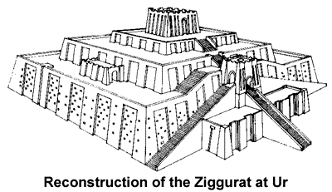

The Sumerians were a creative people. They were the first people to use the wheel for wagons drawn by animals. They invented the potters wheel. They invented imported metals such as bronze and copper, and they used arches and domes in their buildings. In each Sumerian city, many people worked specialized jobs. One could find carpenters, potters, metal-workers, stone cravers, boat builders, jewelers, weapons makers, merchants, scribes (people who kept written records) and religious leaders.
Perhaps the most important contribution of the Sumerians to history was the first written language. The Sumerians did not create the alphabet. At first, they drew pictures to represent objects. Later, the pictures became symbols that represented syllables (part of words). The Sumerians used a pointed stick to press wedge-shape symbols (cuneiform) into soft clay tablets. When these tablets dried and hardened they became the permanent records of business dealings, court proceedings, schoolwork, grain harvest, and laws.

Cuneiform – the world’s oldest written language
