Name:
Section:
How Culturally Diverse is Africa?
Cultural Diversity:

Practice: What makes the United States “diverse”? List reasons

Introduction to African People and Culture
The vast continent of Africa is so rich and diverse in its culture with it not only changing from one country to another but within an individual country many different cultures can be found.
Much of Africa's cultural activity centers on the family and the ethnic group. Art, music, and oral literature serve to reinforce existing religious and social patterns. The Westernized minority, influenced by European culture and Christianity, first rejected African traditional culture, but with the rise of African nationalism, a cultural revival occurred. The governments of most African nations foster national dance and music groups, museums, and to a lesser degree, artists and writers.
Africa was the birthplace of the human species between 8 million and 5 million years ago. Today, the vast majority of its inhabitants are of indigenous origin. People across the continent are remarkably diverse by just about any measure: They speak a vast number of different languages, practice hundreds of distinct religions, live in a variety of types of dwellings, and engage in a wide range of economic activities.
Over the centuries, peoples from other parts of the world have migrated to Africa and settled there. Historically, Arabs have been the most numerous immigrants. Starting in the 7th century, they crossed into North Africa from the Middle East, bringing the religion of Islam with them. A later movement of Arabs into East and Central Africa occurred in the 19th century.
Europeans first settled in Africa in the mid-17th century near the Cape of Good Hope, at the southern end of the continent. More Europeans immigrated during the subsequent colonial period, particularly to present-day South Africa, Zimbabwe, and Algeria. South Asians also arrived during colonial times. Their descendants, often referred to as Indians, are found largely in Uganda, Kenya, Tanzania, and South Africa.
After reading, list reasons why Africa is a culturally diverse continent:

Language of Africa:
Slide 1:
1. Compare the map of Africa to the map of Europe next to it. What are the differences between how the two continents’ languages are divided?

2. Read the following quote: “European colonial powers divvied up sections of the continent with little regard for how the residents organized the land themselves.” Answer the following questions:
a. Why don’t Africa’s language families loosely stick to the country’s borders?

b. How does this quote explain why Africa is so diverse today?

Religion of Africa
Slide 2:
The map is a breakdown of where the major religions are located in Africa. The chart on the right shows the difference in the names of “God” in Africa. Answer the following question:
a. How do these images show the diversity of Africa?

People of Africa
Slide 3:
The pictures on this slide are faces from Africa. Study the differences and similarities. Then answer these questions:
a. What do you notice about the entirety of the picture?

b. Does anything surprise or confuse you?

c. Looking back at your list of reasons why the U.S. is diverse, how does the diversity of Africans compare to the diversity of Americans?
AFRICAN FAMILY CASE STUDIES
Directions: Read the two “African Family Case Studies” and complete the questions so you can organize the similarities and differences between Family Life in Africa and Family Life in the United States.
Introduction
Families and communities are important aspects of cultures and societies. They come in many different shapes and sizes throughout the continent of Africa, so there is no one pattern to describe them. As you know in your own experiences, even next door neighbors can have very different family situations. To illustrate the diversity of family and community life in Africa, two examples have been selected below. You will find that some things about the families and communities in the stories may seem very similar to your own society and personal life. Other things may seem very different. Read the story that goes with each picture below and answer the questions that follow.

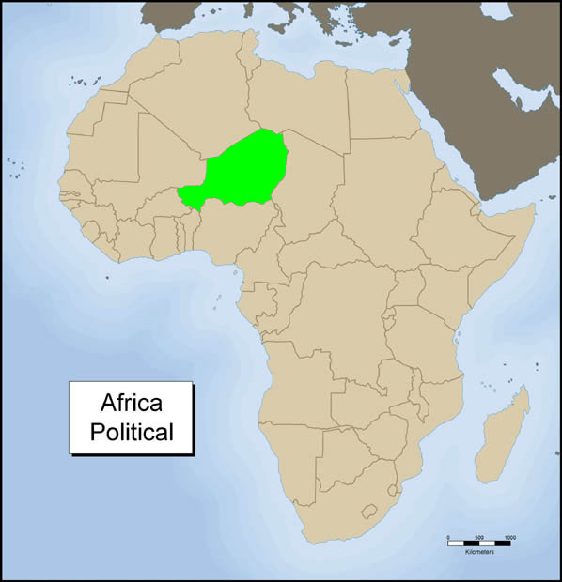
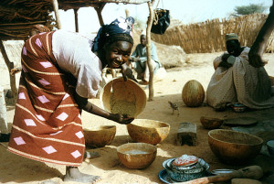
STORY #1

Zainebu is the oldest child in her family. She has three younger brothers and one younger sister. Zainebu is 12 years old and in her sixth year of primary school. She lives in a town in Niger where most people speak a language called Hausa.
Every morning Zainebu wakes up at sunrise and takes two large containers down to the water pump at the end of the street. There she fills them up with water for her family so they can take their morning baths. Zainebu has to get a lot of water! Not only do her brothers and sisters have to take bathes with this water each morning, but also her mother, father, and grandfather. She usually goes to the water pump with her half-sister Hannatu, who gets water for her own mother and two sisters. Zainebu and Hannatu both have the same father, but different mothers. They live in a culture where a man can have more than one wife, so their father has married two women. This kind of marriage is called polygamy.
The girls live together in their father’s family home along with their mothers, brothers, sisters, and grandfather. When families typically live in the father’s family home, this is referred to as a patriarchal culture. There are four small houses in their family home, which is sometimes called a compound. Both Zainebu and Hannatu’s mothers each have their own small house in the compound where they sleep along with their children. The father has his own house, and the grandfather has a house too. What is the fourth house for then? It is the kitchen, where most of the cooking is done.
As Zainebu and Hannatu were walking to the water pump one day, they remembered that it was a special day. Their cousin Mariama from another town was coming to spend her school vacation with them. Mariama’s father and Zainebu and Hannatu’s father are brothers. That means the girls are paternal cousins. Zainebu and Hannatu love having family come and stay with them. They are very close to their extended family. Extended families include relatives beyond just mother, father, brothers, and sisters. Both girls discuss what questions they want to ask Mariama about some of their extended family who live with her. They want to know how their aunt and uncle are doing as well as some of their other cousins.
Questions:
1. What are two things about Zainebu and Hannatu’s life that are similar to your own life?

2. What are two things that are different?

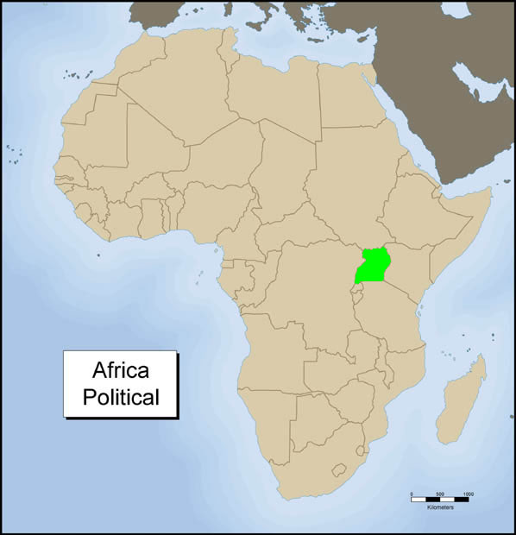
Story #2
David is a student who is in secondary school in Kampala, the capital city of Uganda. Secondary school usually consists of grades 8 through 13 in Uganda. David has gotten used to living and going to school in a big city. Kampala has over one million people living in it. David lives in an apartment with his older brother Eric, grandmother Florence, and cousin Ronald. Except for David’s older brother, his nuclear family lives in another city about 50 miles away from Kampala. A nuclear family usually refers to a mother, a father, and their children.
David likes living in Kampala. He has made some good friends at school who get together twice a week to play soccer. They meet after school and use the school athletic field.
David’s brother Eric came to Kampala to find work. He wanted to save money to send home to his mother and father to help them with expenses for his brothers and sisters. Eric also is starting to save money for his own wedding, which he is hoping will take place in about a year. Eric did well in school and was able to get a degree in accounting. Now he has a job at a bank in Kampala.
David’s cousin Ronald is a good friend of his. Ronald’s mother and David’s mother are sisters. This makes them maternal cousins. Both of them have made friends in the neighborhood with a group that likes to play sports together on the weekends. Often in the evenings, this group of friends congregates outside David’s apartment building to sit and chat as they watch the stars.
David’s favorite nights are when Grandma Florence decides to come out and join him with his friends. She tells them about her life in a small village when she was a girl and how she met her husband years ago. When they were newly married, she and her husband moved to Kampala because her husband got work there as a school teacher. They have lived in Kampala ever since. Five years ago Grandma Florence’s husband passed away, and her three grandsons David, Eric, and Ronald came to live with her. Grandma Florence is their maternal grandmother. That means that she is the mother of their mothers.
1. How is David’s life similar to your own life?

2. How is it different?

3. How is this story similar from Story #1? How is it different?

