Name/Class #:
Section:

Han Dynasty

- What does it mean when an empire is described as “stable”?

Silk Road and Early Chinese Dynasties: Map Study
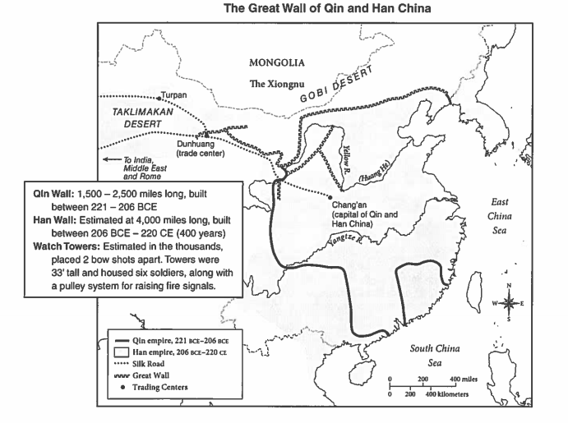
- Examine the map and list three bodies of water, two deserts, and three major trading centers.

- Many Chinese merchants traveled only as far as Dunhuang on the Silk Road. Can you give two reasons why?

- Judging from the map, how might China have benefited from building the Great Wall?

Directions: Read the documents with your group. As you read, complete the chart below. Then use your chart to answer the overall question.

 | Qin Dynasty | Gupta Empire | Han Dynasty
Evidence of creating stability
Evidence of cultural and/or economic achievements | Cultural:  Economic: | Cultural:  Economic: | Cultural:  Economic:

Overall Question:

- In what ways did the Qin, Gupta, and Han Empires create stability? How did this stability lead to cultural and/or economic achievements?

Document 1
Previously a minor state in the northwest, Qin had seized the territories of small states on its south and west borders by the mid-third century B.C., pursuing a harsh policy aimed at the consolidation and maintenance of power. Soon thereafter, Ying Zheng (259—210 B.C.), who would reunite China, came to the Qin throne as a boy of nine. He captured the remaining six of the "warring states," expanding his rule eastward and as far south as the Yangzi River, and proclaimed himself First Emperor of the Qin, or Qin Shihuangdi. Qin, pronounced chin, is the source of the Western name China.
Throughout his rule, Qin Shihuangdi continued to extend the empire, eventually reaching as far south as Vietnam. His vast empire was divided into commanderies and prefectures administered jointly by civil and military officials under the direction of a huge central bureaucracy. This administrative structure served as a model for government in China until the collapse of the Qing dynasty in 1911. Qin Shihuangdi also standardized the Chinese script, currency, and system of measurements, and expanded the network of roads and canals. He is credited with building the Great Wall of China by uniting several preexisting defensive walls on the northern frontier; and reviled for a state-sponsored burning of Confucian works and other classics in 213 B.C.

Source: Department of Asian Art. "Qin Dynasty (221–206 B.C.)". In Heilbrunn Timeline of Art History. New York: The Metropolitan Museum of Art, 2000. http://www.metmuseum.org/toah/hd/qind/hd_qind.htm (October 2000)

Document 2
The Gupta Empire ruled much of India from about 320 to 540 CE and created a golden age for India. The Gupta Empire gave power to the individual villages of the empire and the city governments. During the golden age of the Gupta Empire, trade and farming increased greatly. There were also great advances in learning made during this empire. Students began to be educated in religious schools, although, the students still studied many subjects besides religion such as math, medicine, language, and literature. During this empire, the system of writing that we use now and the decimal system were created. The people of this empire were also very advanced in medicine and literature. There were three main religions in the Gupta Empire, Buddhism, Hinduism, and Jainism, although, the people were mostly Hindus. The Guptas built many Hindu shrines and the religion prospered under their rule. Overall, the Gupta Empire created a golden age that resulted in many great advances for India.

Source: "The Gupta Empire (Overview)." World History: Ancient and Medieval Eras. ABC-CLIO, 2011. Web. 10 Jan. 2011. Gaynor Ellis, Elisabeth, and Anthony Esler. World History. United States of America: Pearson Education, 2009. Print (adapted)

Document 3

Under the Han Dynasty, ideas attributed to the philosopher Confucius (Kong Zi) were recorded, systematized, and propagated as a code of conduct. During his lifetime, (551-479 B.C.E.), Confucius had been preoccupied with the decline of the Zhou Dynasty. He extolled the virtues of a society based on each person’s performance of his given role…[The Han Dynasty] Government by officials was invigorated by meritocratic selection. The emperor recruited not from an aristocracy but from the sons of landowners, and in 124 BCE he created an imperial academy-some call it a university-to train them in techniques of rule, record keeping, and Confucian ideals. By 1 CE a hundred men a year were passing examinations by scholars and entering the bureaucracy.

Source: Jane Burbank and Frederick Cooper. Empires in World History. New Jersey: Princeton University Press, 2010.

