Name:
Section:
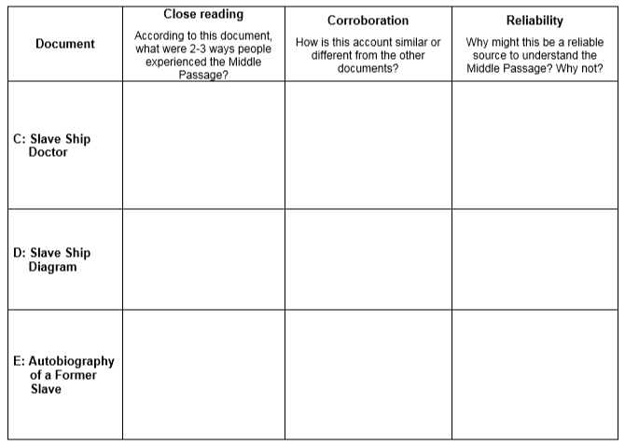
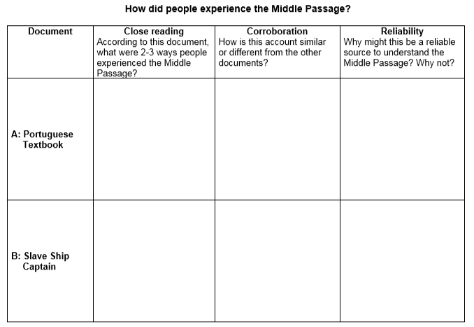

Final Question: (Homework)
In 8-10 complete sentences, which of these documents do you believe is the most reliable source of information about the Middle Passage? Select no more than two and explain your selection using evidence from the Graphic Organizer.

