Name: Section:
Feudalism (Day 5)
Part One:
CAUSE: Viking, Magyar (Hungarian), and Muslims invade Western Europe from 800-1000.

EFFECTS: (List Below)

- Circe the above “effect” that YOU believe most impacted Western Europe. Explain below.

Part Two: PPT Notes
- Why did Feudalism arise?

- What is Feudalism?

- How long does the Feudalism system last?

- What is the Manorial System?

Part Three: Document Analysis
Directions: Analyze the documents and answer the short-answer questions that follow each document in the space provided. These answers will help you answer the overall question.

Document 1: This excerpt describes Europe in the 800s and 900s AD. (1922 text)
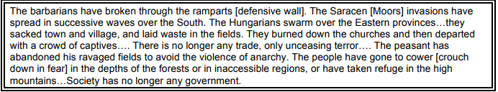
- According to the author, what were conditions like in Europe during the 800s?

Document 2:
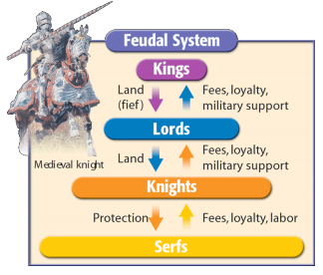
2. Explain the mutual obligations as illustrated in this diagram.

Document 3:
This excerpt describes the honor code medieval knights were expected to abide by. (1470)
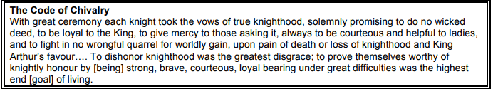
3. According to this document, what are the main characteristics of chivalry?

Document 4:
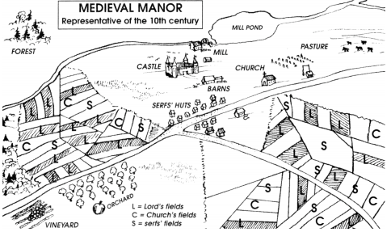
4. How does this map help you better understand the organization of a medieval manor?

Document 5:
Tenants on a manor owed services to their lord. Some of these services are listed below: (1283-1312)
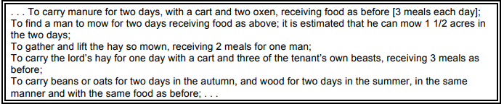
5. State one benefit that the lord received under manorialism

6. State one benefit that the tenants received under manorialism

Document 6: (Textbook)
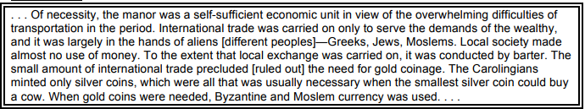
7. What are two ways manorialism influenced the economy of Europe?

Part Four: Overall Question:

- How did feudalism and the manorial system work during the Middle Ages? Use three documents above to answer this question.

Ex. Document ____ shows how the feudal/manorial system worked during the Middle Ages because…

