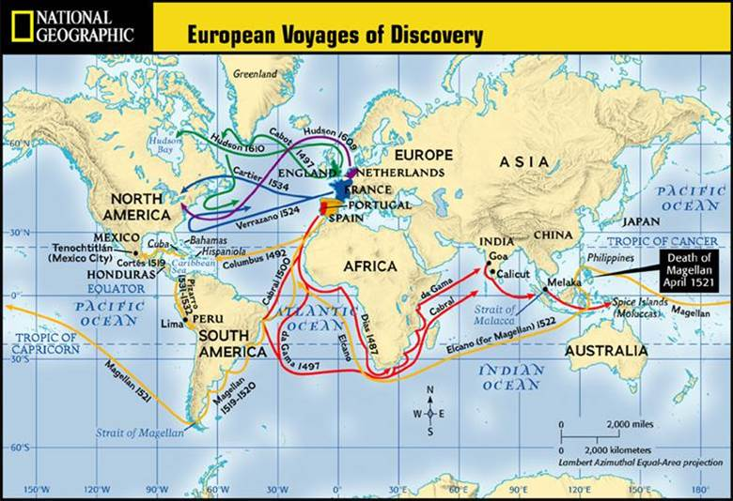
Questions:
1. What modern nations did Spanish explorers sail to?
2. What modern nations did English explorers sail to?
3. What modern nations did French explorers sail to?
4. What would motivate these Europeans to venture into unknown lands and risk death?
William Henry Powell’s Discovery of the Mississippi, 1853
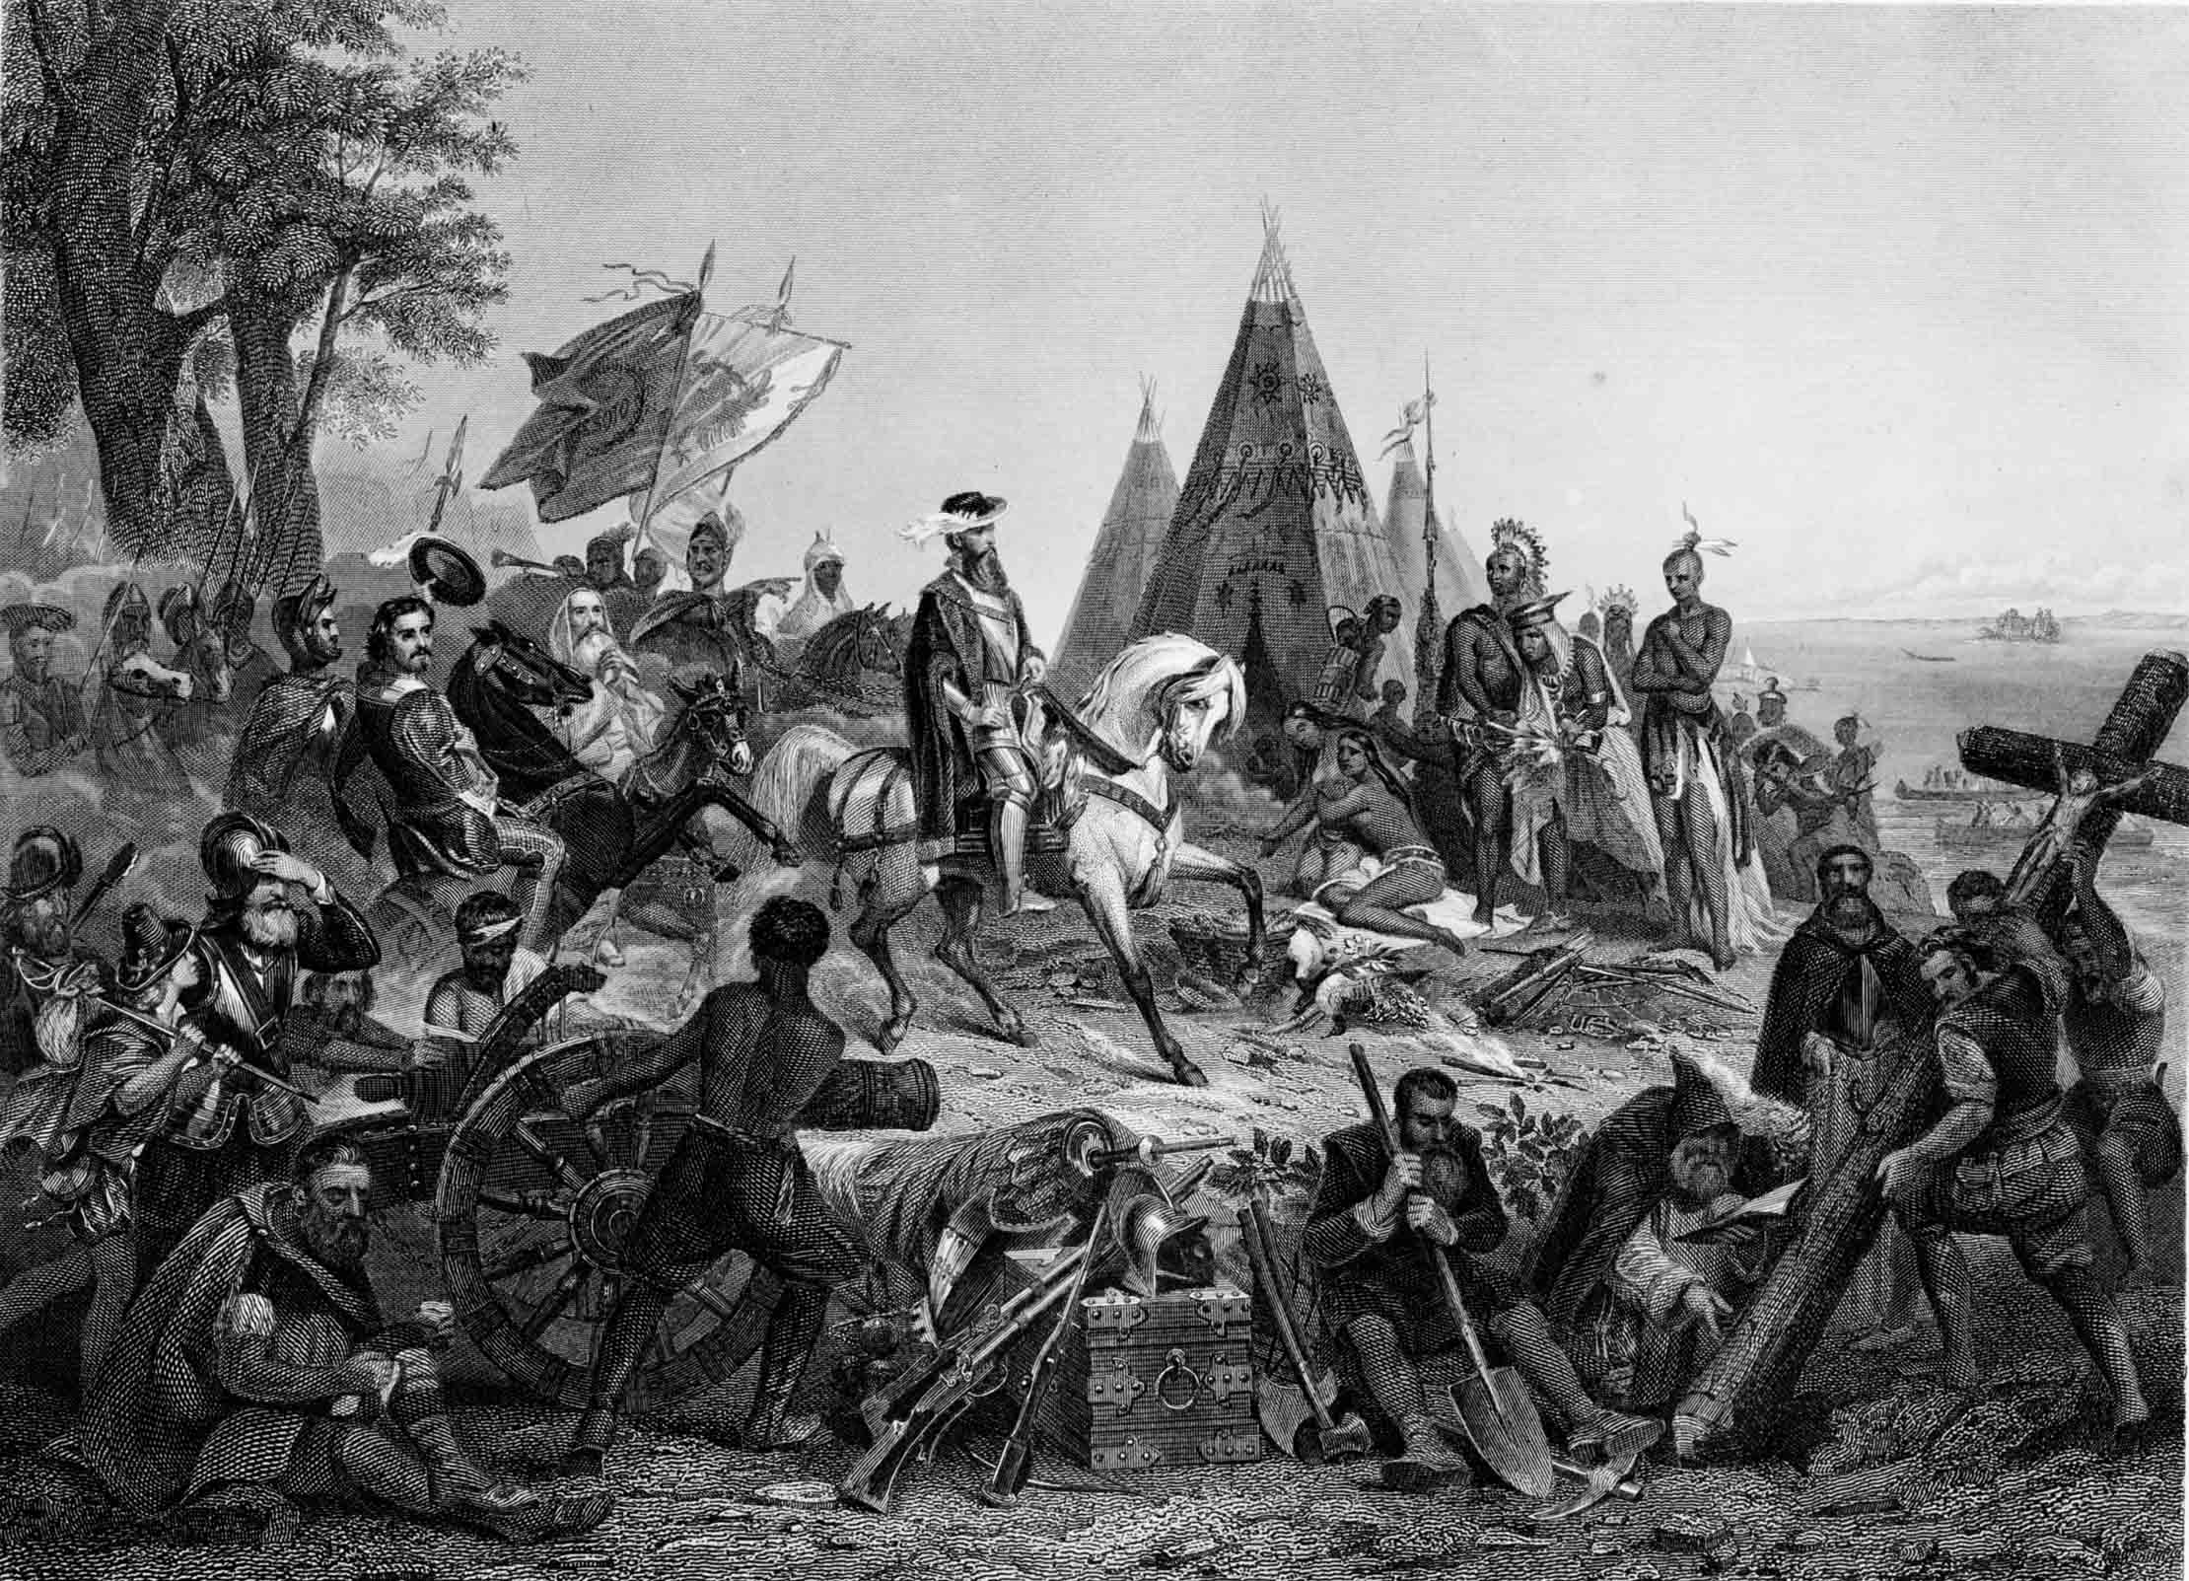
Background Information:
--This painting was made in 1853, three hundred years after the event portrayed

--The main figure of this painting is Hernando de Soto, a Spanish explorer who led the first Europeans to visit the Mississippi River and parts of southeastern North America

Questions:
1. Identify three figures wearing different types of clothing in this painting. Attempt to give each a job title.
2. What items in this painting display power? Religion?
3. How can this painting relate to what motivated the Spanish to explore and colonize the world?
Twenty-ninth Chapter of the “Florentine Codex”, in which it is told how there came a plague, of which the natives died. Its name was smallpox. It was at the time that the Spaniards set forth from Mexico.
“But before the Spaniards had risen against us, first there came to be prevalent a great sickness, a plague. It was in Tepeilhuitl that it originated, that there spread over the people a great destruction of men. Some it indeed covered [with pustules]; they were spread everywhere, on one's face, on one's head, on one's breast, etc. There was indeed perishing; many indeed died of it. No longer could they walk; they only lay in their abodes, in their beds. No longer could they move, no longer could they bestir themselves, no longer could they raise themselves, no longer could they stretch themselves out face down, no longer could they stretch themselves out on their backs. And when they bestirred themselves, much did they cry out. There was much perishing. Like a covering, covering-like, were the pustules. Indeed, many people died of them, and many just died of hunger. There was death from hunger; there was no one to take care of another; there was no one to attend to another.”

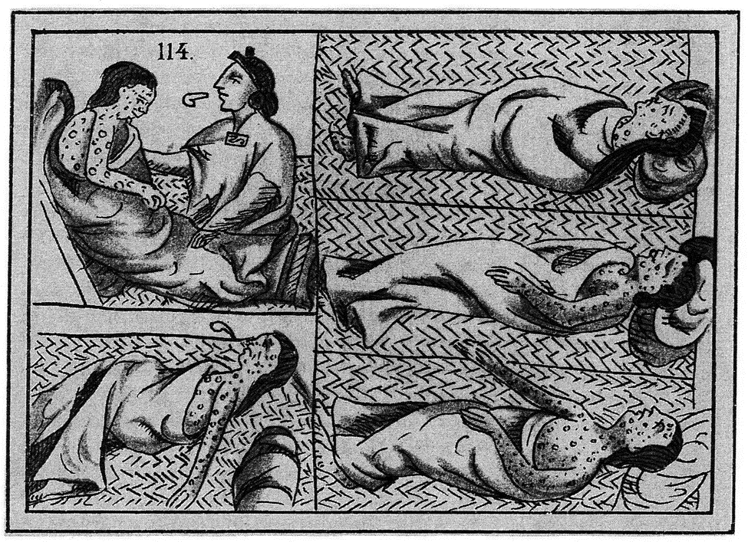
Questions:
- Why do you think people died of "famine" during this epidemic?

- What story does the image of the epidemic tell? What does the pictorial story add to the written description?

Pizarro Seizing the Inca of Peru by John Evertt Millais, 1846
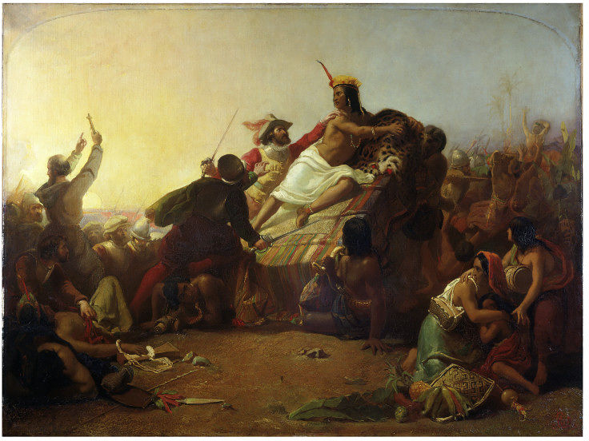
Questions:
1. If you know this is an image of Incan conquest, who can you identify in the image?
2. How does Millais portray the Spanish? The Incas?

