Name:
Comparing Athens and Sparta: Day 2

Part One: Why did Greece create city-states?

City-State: Consists of a city and its surrounding countryside of about 50-500 square mile. Population less than 10,000. (context: St. Louis County is 523 square miles)

Using the definition of city-state, brainstorm answers to the following questions:
- What are advantages of the city-states as a form of government?

- What are disadvantages of city-states as a form of government?

Part Two: How did city-states impact politics?
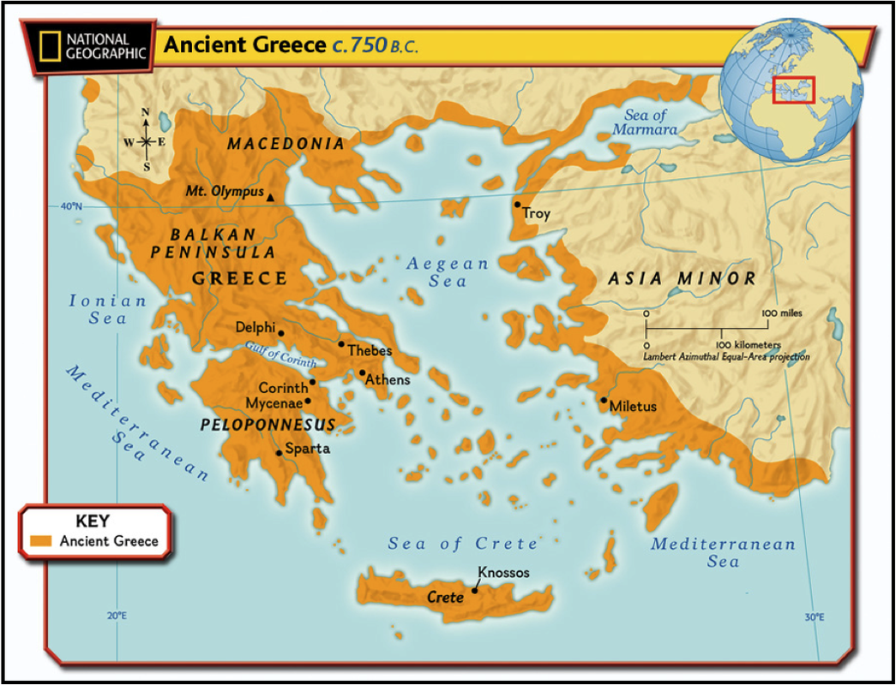
- Based on the map, why do you think ancient Greeks developed city-states rather than a unified nation?

- What were the various political structures that were created because of city-state formation?

Part Three: Athens vs. Sparta
 | Athens | Sparta
Government Structure
Social Structure
Part Four: Document Analysis

Document 1: “A Husband’s Advice”

- What is the husband suggesting in his advice to his wife?

- How is the husband’s advice representative of Athenian attitudes toward women?

Document 2: “A Powerful Fighting Force”

- What quality greatly valued by the Greeks is shown on the pottery?

