Name:
Section:

Urbanization and the Two Chinas

Background: Below are two charts that illustrate many of the important factors that contribute to the inequality in China and the accompanying urbanization. Please use the information in the graphs to answer the questions below.

Chart Reading Part 1:
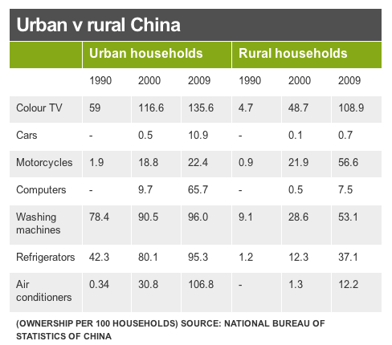
1) Use the graph to identify two specific ways that the standard of living in urban households is higher than that in rural households.

2) In what ways does the mode of transportation likely differ depending on where a family lives in China? Why is this important?

3) Rank these seven machines and appliances in order of importance with one being the most important for a quality standard of living and seven being the least important. Support your opinions as best you can.

Chart Reading Part 2:

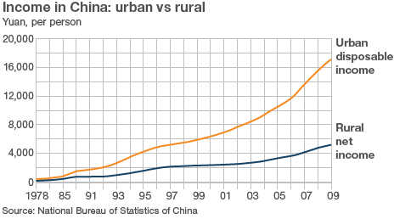

4) There are about six yuan per one U.S. dollar. Do the conversion to understand how many dollars a rural dweller makes in a year. How do you think this compares to the average income in the U.S.?

5) “Disposable income” is the money left over after you have paid for necessities like food and housing. Net income is all the money one makes in a year. In what ways do these definitions alter your understanding of the graph.

6) Why do you think the Chinese government uses the hukou system to control the movement of Chinese citizens?

