Text Analysis

Excerpt 1
In this excerpt, Mann offers an overview of the Columbian Exchange with examples.
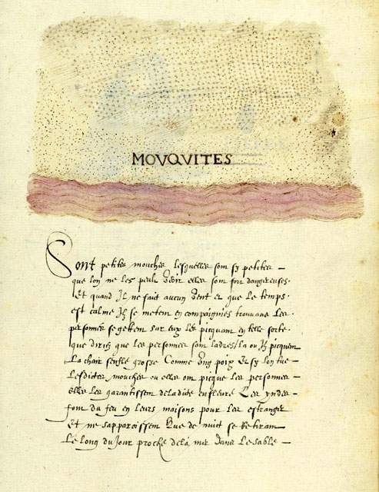
…Colon [Columbus] and his crew did not voyage alone. They were accompanied by amenagerie of insects, plants, mammals, and microorganisms. Beginning with La Isabela [Colon’s first settlement], European expeditions brought cattle, sheep, and horses, along with crops like sugar cane (originally from New Guinea), wheat (from the Middle East), bananas (from Africa), and coffee (also from Africa). Equally important, creatures the colonists knew nothing about hitchhiked along for the ride. Earthworms, mosquitoes, and cockroaches; honeybees, dandelions, and African grasses; rats of every description — all of them poured from the hulls of Colon’s vessels and those that followed, rushing like eager tourists into lands that had never seen their like before.
Movqvites (Mosquito), “Histoire Naturelle
des Indes,” ca. 1586

Cattle and sheep ground the American vegetation between their flat teeth, preventing the regrowth of native shrubs and trees. Beneath their hooves would sprout grasses from Africa, possibly introduced from slave ship bedding; splay-leaved [with wide leaves] and dense on the ground, they choked out native vegetation. (Alien grasses could withstand grazing better than Caribbean groundcover plants because grasses grow from the base of the leaf, unlike most other species, which grows from the tip. Grazing consumes the growth zones of the latter but has little impact on those in the former.) Over the years forests of Caribbean palm, mahogany, and ceiba [the silk-cotton tree] became forest of Australian acacia [small tree of the mimosa family], Ethiopian shrubs, and the Central American logwood. Scurrying below, mongooses from India eagerly drove Dominican snakes toward extinction. The changes continue to this day. Orange groves, introduced to Hispaniola from Spain, have recently begun to fall to the depredation of lime swallowtail butterflies, a citrus pest from Southeast Asia that probably came over in 2004. Today Hispaniola has only small fragments of its original forest.

Excerpt 2
Here Mann gives a specific example of unintended consequences.
Natives and newcomers interacted in unexpected ways, creating biological bedlam. When Spanish colonists imported African plantains [a tropical plant that resembles a banana] in 1516, the Harvard entomologist Edward O. Wilson has proposed, they also imported scale insects, small creatures with tough, waxy coats that suck the juices from plant roots and stems. About a dozen banana-infesting scale insects are known in Africa. In Hispaniola, Wilson argued, these insects had no natural enemies. In consequence, their numbers must have exploded — a phenomenon known to science as “ecological release.” This spread of scale insects would have dismayed the island’s European banana farmers but delighted one of its native species: the tropical fire ant Solenopsis geminata. S. geminata is fond of dining on scale insects’ sugary excrement; to ensure the flow, the ants will attack anything that disturbs them. A big increase in scale insects would have led to a big increase in fire ants.
So far this is informed speculation. What happened in 1518 and 1519 is not. In those years, according to Bartolome de Las Casas, a missionary priest who lived through the incident, Spanish orange, pomegranate, and cassia plantations were destroyed “from the roots up.” Thousands of acres of orchards were “all scorched and dried out, as though flames had fallen from the sky and burned them.” The actual culprit, Wilson argued, was the sap-sucking scale insects. But what the Spaniards saw was S. geminata — “an infinite number of ants,” Las Casas reported, their stings causing “greater pains than wasps that bite and hurt men.” The hordes of ants swarmed through houses, blackening roofs “as if they had been sprayed with charcoal dust,” covering floors in such numbers that colonists could sleep only by placing the legs of their beds in bowls of water. They “could not be stopped in any way nor by any human means.”… Overwhelmed and terrified, Spaniards abandoned their homes to the insects….

Excerpt 3
Mann explains the most “dramatic impact of the Columbian Exchange.”
From the human perspective, the most dramatic impact of the Columbian Exchange was on humankind itself. Spanish accounts suggest that Hispaniola had a large native population: Colón, for instance, casually described the Taino as “innumerable, for I believe there to be millions upon millions of them.” Las Casas claimed the population to be “more than three million.” Modern researchers have not nailed down the number; estimates range from 60,000 to almost 8,000,000. A careful study in 2003 argued that the true figure was “a few hundred thousand.” No matter what the original number, though, the European impact was horrific. In 1514, twenty-two years after Colon’s first voyage, the Spanish government counted up the Indians on Hispaniola for the purpose of allocating them among colonists as laborers. Census agents fanned the across the island but found only 26,000 Taino. Thirty-four years later, according to one scholarly Spanish resident, fewer than 500 Taino were alive….
Spanish cruelty played its part in the calamity, but its larger cause was the Columbian Exchange. Before Colon none of the epidemic diseases common in Europe and Asia existed in the Americas. The viruses that cause smallpox, influenza, hepatitis, measles, encephalitis, and viral pneumonia; the bacteria that cause tuberculosis, diphtheria, cholera, typhus, scarlet fever, and bacterial meningitis — by a quirk of evolutionary history, all were unknown in the Western Hemisphere. Shipped across the ocean from Europe these maladies consumed Hispaniola’s native population with stunningrapacity. The first recorded epidemic, perhaps due to swine flu, was in 1493….
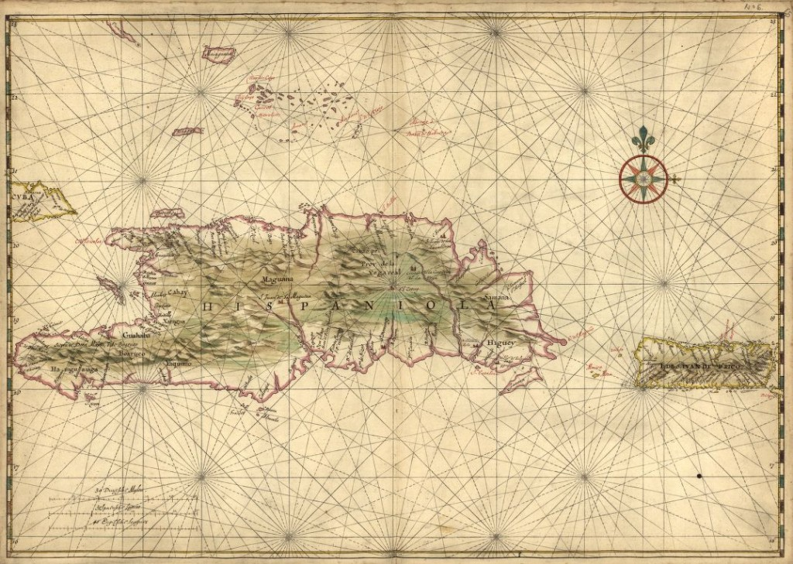
Joan Vinckeboons, “Map of the islands of Hispaniola and Puerto Rico,” 1639(?)

Vocabulary Pop-Ups
- menagerie: collection of wild or unusual animals
- alien: foreign, hostile
- depredation: ravages
- bedlam: wild confusion
- entomologist: insect expert
- phenomenon: observable event or fact
- dismayed: alarmed
- speculation: thoughtful opinion
- culprit: villain
- horrific: causing horror
- fanned: spread out
- calamity: great disaster
- quirk: peculiar action
- maladies: chronic diseases
- rapacity: fierce hunger

Text:
- Charles C. Mann, 1493: Uncovering the New World Columbus Created (New York: Vintage Books, 2012).

Close Reading Questions
Excerpt 1:

1. Why do you believe Columbus brought cattle, sheep or horses with him?
They were part of the European culture. They would help in farming (cattle and sheep) and communication, transportation, and war (horses). The Spanish intended to start a colony and would need the animals.
2. What would the Taino culture have been like without cattle or horses?
There would have been communication only by human messenger and fields planted by hand. There would have been no quick communication (by horse) or plowed fields or pastures (no cattle, so they were not possible or necessary) and only a few, small paths, no real roads (the only transportation was by foot).
3. What is the thesis statement of paragraph 1? How does Mann develop that thesis? Cite evidence from the text.
The thesis is “Colon and his crew did not voyage alone.” Mann develops that thesis by giving examples to prove his point, including earthworms, cockroaches, African Grasses, rats, and other animals and plants.
4. How did the introduction of cattle and sheep affect plant life on Hispaniola?
New grasses for grazing choked out native species.
5. Why is it important that alien grasses, trees, and other plants choked out native vegetation in Hispaniola?
Choking out native grasses reduced the biodiversity (the number of distinct life forms) of Hispaniola. Ecosystems that are more biodiverse (they have more distinct life forms) are more productive and are more resistant to diseases.
6. What can be the effect of introducing a new predator into an environment, such as the Indian mongoose in Hispaniola? Give an example.
It can render another species extinct, which may itself have unintended consequences. For instance, the food source for the Dominican snake may have increased in population which may have led to other effects.
7. How does Mann show that the Columbian Exchange is still ongoing?
He relates how, in 2004, the orange groves have become prey of the lime swallowtail butterflies.
8. In the second paragraph of this excerpt, Mann implies his thesis but does not actually state it. What is the implied thesis of paragraph 2? How does he imply the thesis?
Mann implies that the Columbian Exchange can have negative results. He gives examples, citing grasses that were choked out, trees that were replaced with other types of trees, and animals driven toward extinction.
Close Reading Questions
Excerpt 1:

9. According to the author and his sources, what unintended import came in to Hispaniola with plantains?
With the plantains came scale insects.
10. How does the author define scale insects?
They are small creatures with tough, waxy coats that suck the juices from plant roots and stems.
11. Define “ecological release.”
Ecological release is when an invasive species is introduced into an environment with no natural predators and subsequently the population explodes.
12. Using the example of scale insects as evidence, why are natural predators important to an ecosystem?
They help to regulate the population of a species and keep an ecosystem in balance.
13. What was the unintended effect of this import, scale insects, according to Wilson? Why did they have this effect?
The scale insects sucked juices from plants and stems. They had no natural enemies, so their populations grew greatly. The scale insects became a food source for fire ants. With a virtually unlimited food source, the fire ant population grew greatly. The fire ants invaded settlers’ homes. This proved to be dangerous to the settlers.
14. Mann begins the second paragraph in this excerpt with “So far this is informed speculation.” What effect does this admission have on our perception of Mann as an author?
It reminds the reader that Mann is approaching his topic from a scientific perspective, being careful to alert readers to what is proven and what is not. This helps to establish him as a writer we can trust.
15. What document from the 1500s seems to confirm this unintended effect?
Bartolome de Las Casas wrote of a sudden infestation of fire ants in 1518 and 1519.
16. What was the unintended effect to settlers of the introduction of plantains to Hispaniola?
Although they had plantains to eat, they also had to deal with fire ants. As a result, they abandoned their homes.
17. How does Mann combine 16th and 20th century evidence?
He uses 20th century science to explain a 16th century eye-witness account.
Close Reading Questions
Excerpt 3:

18. What is the thesis of this excerpt?
Mann asserts that “the most dramatic impact of the Columbian Exchange was on humankind itself.”
19. What evidence does Mann use to develop this thesis?
He uses Columbus’s original account, 16th century official Spanish documents, and estimates by modern historians.
20. Why did the Spanish conduct a census of the Indians on Hispaniola in 1514? What did the census find regarding the Taino population?
The Spanish conducted a census in order to count the Taino so that they could be assigned to Spanish settlers as laborers. This was part of the encomienda system, whereby a Spanish settler was given a plantation as well as the labor of all the Indians who lived on that plantation. The census-takers found that there were few Taino left, perhaps only about 26,000.
21. According to the author, what two factors caused this change in population? Which cause was the most influential?
The two causes were Spanish cruelty and the introduction of diseases by the Columbian Exchange. The most influential was the introduction of disease.
22. The third sentence in paragraph 2 of this excerpt uses a rhetorical device called asyndeton. Asyndeton is a list of items with conjunctions omitted and can be used to imply that there are more items that could be added to the list. What types of items does the author list using asyndeton? What is the effect?
The author lists diseases, both viruses and bacteria. The effect is a “piling up”, implying that more diseases were brought to Hispaniola as well, but the author may not have the space in the sentence to list them. In fact, other diseases were introduced by the Columbian Exchange, including malaria, yellow fever, whooping cough, chicken pox, the bubonic plague, and leprosy.
23. Why was the introduction of these diseases so devastating for the Taino and not the Spanish explorers?
The Taino had never been exposed to these diseases before and therefore had no natural immunity to stop or control the spread of the disease. The Spanish did have some natural immunity, since the diseases were present in Europe at that time.
24. What is the effect of Mann including the information about the first recorded epidemic, which occurred within one year of Columbus’s arrival?
He reminds the reader that the devastating effects of diseases brought by the Exchange happened almost immediately for the Taino. This conveys the seriousness of the Exchange as well as the power of the diseases in a population with no natural immunity.

