Name: Section:
Absolutism (Day 2)

Define Absolutism:

What attributes are necessary for a monarch to be absolute?

Part Two: Examples of Absolutism
Directions: Read each example and complete the graphic organizer below.
Example 1
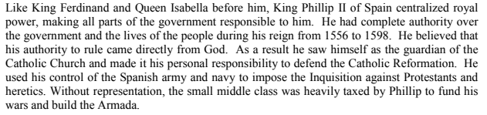
Example 2
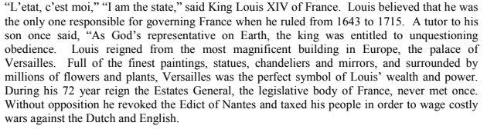
Example 3
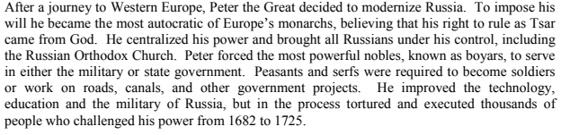
Example 4
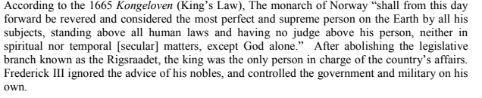
Example Number | Type of Leader | What power does the leader have? | Where does the leader’s power come from? | Are there any checks and balances? How do you know?
1
2
3
4

Part Three: Create your own Absolute Ruler
Directions: In the space below, in 3-5 sentences, create your own absolute monarch example. Make sure to include the three attributes that are necessary for a ruler to be absolute. Include a creative name and country for your ruler.

____________________________________________________________________________________________________________________________________________________________________________________________________________________________________________________________________________________________________________________________________________________________________________________________________________________________________________________________________________________________________________________________________________________________________________________________________________________________________________________________________________________________________________________________________________________________________________________________________________________________________________________________________________________________________________________________________________________________________________________________________________________________________________________________________________________________________________________________________________________________________________________________________________________________________________________________________________________________________________________________________________________________________________________________________________________________

